A Project Report On

SUICIDES IN UTTAR PRADESH, INDIA FROM 2001-2012

## ACKNOWLEDGEMENT

It is matter of great privilege to me to submit this project entitled **“*Suicides in Uttar Pradesh, 2001-2012*”** based on the secondary data taken from the reports published by the National Crime Records Bureau of India, which works as a part of Ministry of Home Affairs of India.

## CONTENTS

|  |  |
| --- | --- |
| 1.INTRODUCTION | 1- 2 |
| 2.OBJECTIVES | 3- 4 |
| 3.ANALYSIS | 5- 39 |
| 4.CONCLUSION | 40- 41 |

INTRODUCTION

According to the reports of WHO, about 8.00 lakh people die by suicide worldwide every year. India which has about 17.5% of world’s population has about 1.35 lakhs registered cases of suicides which forms about 17% of the world’s share. Data from various agencies have reflected one thing in commonality, increase in suicide rates amongst Indians. The data amongst various age groups may vary year on year basis, but it has shown an increasing trend.

One can blame anything ranging from parental, societal or peer pressure, expectations to conflicts or mental condition; but one thing is for sure we as a society has done nothing substantial till date to acknowledge this issue.

One interesting thing which is also observed that people dying by suicide comes from all strata of society, though the number may be high for the lower- middle income groups but we can't ignore the fact that the well-read ones are also sailing on the same boat.

Even in this critical time when our country is hit by global pandemic of COVID-19, we have reported over 300 deaths from mid-March to April (45 days), due to distress triggered by various factors.

According to some reports, despite having a suicide rate higher than the global average, India has not acted on the WHO recommendations for suicidal

prevention. WHO has proposed following the public health model for suicide prevention, consisting of four steps:

* Surveillance
* Identification of risks and protective factors
* Development & evaluation of interventions
* Implementation

The [National Crime Records Bureau](http://ncrb.gov.in/)’s (NCRB) annual report for suicides in India was last published in 2016 (data for year 2015).

## OBJECTIVES

### The study was conducted keeping following primary objectives in mind-

* Descriptive analysis of number of Suicides in the state of Uttar Pradesh from 2001-2012.
* To test if age group and gender significantly affect the average number of suicides in Uttar Pradesh.
* To test if average number of suicides in Uttar Pradesh vary with educational qualification.
* To find a possible trend in the average number of suicides in students of Uttar Pradesh.
* Suicides in people associated with farming or other agricultural activities.

HYPOTHESIS

### The study has following hypothesis for different objectives-

1.

HOA: Average number of suicides in UP are same in males and females.

H1A: Average number of suicides in UP are different in males and females

V/S

HOB: Average number of suicides in UP are same in different age groups.

H1B: Average number of suicides in UP are different in different age groups.

1. HO: Average number of Suicides in UP is independent of Educational Status.

H1: Average number of Suicides in UP depends on Educational Status.

# ANALYSIS

DESCRIPTIVE ANALYSIS

Following I am representing Yearly total number of suicides in Uttar Pradesh from 2001 to 2012 as taken from the reports published by the National Crime Records Bureau of India, which works as a part of Ministry Of Home Affairs of India.

Table: 1.1 Yearly total numbers of suicides in the state Uttar Pradesh

|  |  |
| --- | --- |
| Year | Number of  Suicides |
| 2001 | 17580 |
| 2002 | 21250 |
| 2003 | 18315 |
| 2004 | 18185 |
| 2005 | 17245 |
| 2006 | 15495 |
| 2007 | 19610 |
| 2008 | 20440 |
| 2009 | 20790 |
| 2010 | 18140 |
| 2011 | 24195 |
| 2012 | 22107 |

Graph 1.1: Yearly representation of total number of Suicides in Uttar Pradesh

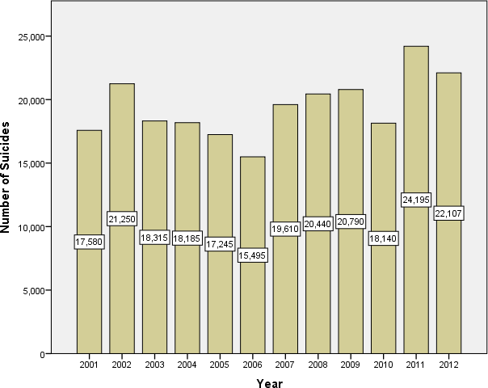

Graph 1.1 represents the total number of suicides in the years 2001 to 2012 in the state of Uttar Pradesh according to the reports of NCRB, India. It is clear from the Graph that the maximum number of suicides were recorded in the year 2011 (24,195) and minimum in the year 2006 (15,495) whatever reason may be for that. No significant trend was found in the number of suicides in Uttar Pradesh with respect to time.

#### Total number of suicides in Uttar Pradesh according to different Age groups and Gender-

Table 1.2: Total number of suicides distributed according to age- and gender- of Uttar Pradesh from 2001-2012

|  |  |  |  |  |  |  |
| --- | --- | --- | --- | --- | --- | --- |
| **Gender** | **Age** | | | | | |
| **0-14** | **15-29** | **30-44** | **45-59** | **60+** | **Total** |
| **Female** | 2667 | 34296 | 18264 | 6627 | 2947 | 43224 |
| **Male** | 2090 | 27144 | 25308 | 14688 | 5961 | 50136 |
| **Total** | 4757 | 61440 | 43572 | 21315 | 8908 | 93360 |

Graph 1.2: Total number of suicides distributed age- and gender- wise in Uttar Pradesh from 2001-2012

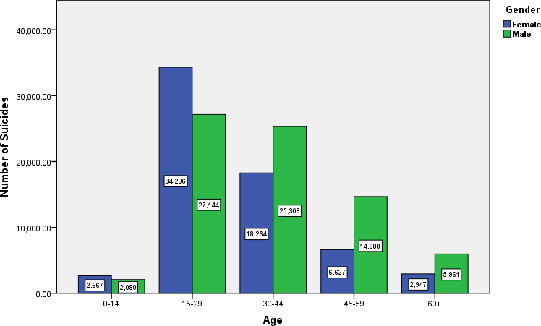

The graph shows the representation of number of suicides in Uttar Pradesh from the year 2001 to year 2012 in males and females of different age groups. Number of suicides in females is more than in males in the age groups 0-14 & 15-29 year. For the rest of the age group the numbers of suicides cases are higher in number for males. It is worthwhile to mention that the maximum suicides among males and females are occurring in the age group 15- 29 years. This data is in agreement with the world’s report of WHO stating highest number of suicides to be committed by the people in age group 15-29 years and also, with the data for whole India. Surprisingly from the Graph and the Table it can be seen that there are suicide cases in young kids whose age is less than 15 years in both the genders. Also there are suicide cases even after age 60 years and above and it is double among males than females. It is observed from the Graph that with respect to female there are almost more than double suicide in males in the age group 45-49 years.

#### Total number of suicides in Uttar Pradesh by Different Causes of suicide-

Table 1.3: Total number of suicides distributed by different causes of suicides in Uttar Pradesh from 2001-2012

|  |  |
| --- | --- |
| Causes | Number of Suicides |
| Bankruptcy or Sudden change in Economic  Status | 461 |
| Cancellation/Non-Settlement of Marriage | 536 |
| Cancer | 328 |
| Death of Dear Person | 141 |
| Divorce | 230 |
| Dowry Dispute | 4606 |
| Drug Abuse/Addiction | 1210 |
| Failure in Examination | 1429 |
| Fall in Social Reputation | 664 |
| Family Problems | 9733 |
| Ideological Causes/Hero Worshipping | 51 |
| Illegitimate Pregnancy | 187 |
| Illness (Aids/STD) | 292 |
| Insanity/Mental Illness | 1880 |
| Love Affairs | 2166 |

|  |  |
| --- | --- |
| Not having Children (Barrenness/Impotency | 584 |
| Other Prolonged Illness | 3227 |
| Paralysis | 95 |
| Physical Abuse (Rape/Incest Etc.) | 264 |
| Poverty | 668 |
| Professional/Career Problem | 301 |
| Property Dispute | 686 |
| Suspected/Illicit Relation | 1212 |
| Unemployment | 907 |
| Other Causes/ Cause not known | 14822 |

Graph 1.3: representing total number of suicides distributed by different causes of suicides in Uttar Pradesh from 2001-2012

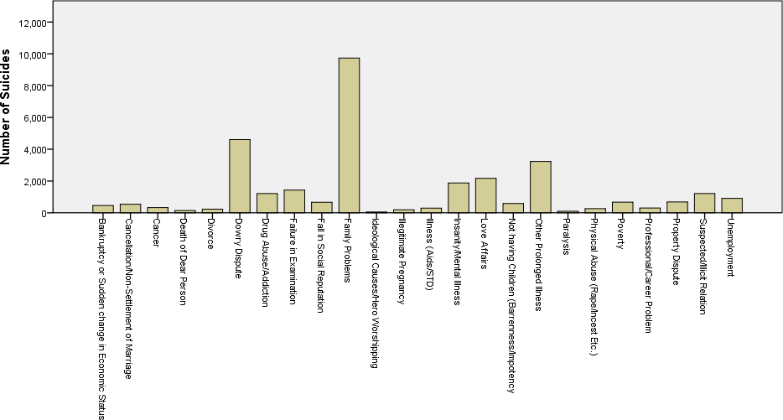

Graph 1.3 represents total number of suicide cases due to different causes that happened in the state of Uttar Pradesh from the year 2001 to 2012.

Family problems are the most prevalent known cause of suicide cases (9733 cases) while ideological causes/hero worshipping is the least common known

cause of the same (51 cases). The second and third most common cause being dowry disputes (4606 cases) and prolonged illness (3227 cases) amongst known causes. Though the number of unknown causes is quite high (14822 cases), there is no significant trend observed in the whole data. The two highest known causes, family problems and dowry disputes together made about 45% of the total suicide cases, amongst known, in Uttar Pradesh from the year 2001 to 2012

#### Total number of suicides according to the Educational Status –

Table 1.4: Total number of suicides distributed by educational qualification in Uttar Pradesh from 2001-2012

|  |  |
| --- | --- |
| **Educational Qualification** | **Number of**  **Suicides** |
| No Education | 11248 |
| Primary | 9337 |
| Middle | 8942 |
| Matriculate/Secondary | 8617 |
| Hr. Secondary/Intermediate/  Pre-University | 5999 |
| Diploma | 641 |
| Graduate | 1513 |
| Post Graduate and Above | 383 |

Graph 1.4: Total number of suicides distributed by educational qualification in Uttar Pradesh from 2001-2012

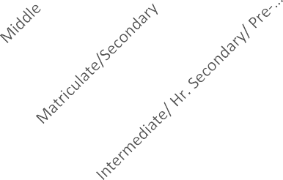

Number of Suicides

12000

11248

10000

9337

8942

8617

8000

5999

6000

4000

2000

1513

383

641

0

Graph 1.4 represents number of suicide cases with respect to educational qualification in the state of Uttar Pradesh from the year 2001 to 2012. It is observed that the highest number of cases are of people with no education (11248 cases) while the least are amongst people with highest qualification of post graduate or others (383 cases). A general decreasing trend is observed in the number of suicide cases as a person gets higher educational qualification

#### Total number of suicides in Uttar Pradesh according to Professional profile-

Table 1.5: Total number of suicides distributed by professional profile in Uttar Pradesh from 2001-2012

|  |  |  |  |
| --- | --- | --- | --- |
| Professional Profile | No. of Suicides | | |
| Female | Male | Total |
| Farming/Agriculture  Activity | 1162 | 5692 | 6854 |
| House Wife | 12476 | 0 | 12476 |
| Professional Activity | 86 | 820 | 906 |
| Public Sector  Undertaking | 206 | 500 | 706 |
| Retired Person | 44 | 118 | 162 |
| Self-employed (Business  activity) | 182 | 1833 | 2015 |
| Service (Government) | 288 | 523 | 811 |
| Service (Private) | 865 | 2562 | 3427 |
| Student | 1344 | 1745 | 3089 |
| Unemployed | 624 | 3426 | 4050 |
| Others | 4300 | 7836 | 12136 |

Graph 1.5: Total number of suicides distributed by professional profile in Uttar Pradesh from 2001-2012



14000

12476

12000

10000

8000

6000

5692

**Female**

4000

3426

2562

1833

2000

~~116~~2

1344

1745

**Male**

0

820

86

865

206

500

44118

182

288

523

624

0

Number of Suicides

Graph 1.5 represents number of suicide cases with respect to professional profile of individuals in Uttar Pradesh from the year 2001 to 2012. Here we observed that the highest number of suicides in females have happened in the case of Housewives (with 12476 case). Though in all other professions, number of males have outnumbered females.

Interestingly, the major profession where males have died by suicide is Farming / Agriculture sector (5692), while unemployed males also forms a major portion of the cases (3426). In totality also the same trend is observed

#### Total Percentage distribution of suicides according to professional profile-

Graph 1.6: Percentage distribution of total number of suicides by professional profile in Uttar Pradesh from 2001-2012

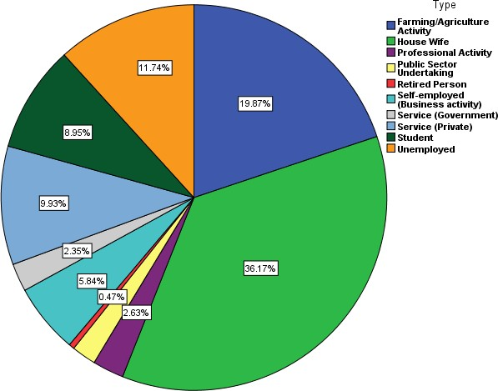

Graph 1.6 shows graphical representation in form of pie chart, of above data depicting percentage of suicide cases with respect to professional profiles of

individuals. Here, we have observed that the four major constituents are Housewives (36.17%), farmers (19.87%), unemployed (11.74%) & students (8.95%) and all these take up more than 76% of the total number of the suicides happened in Uttar Pradesh from the year 2001 to 2012. Hence, the above 76% population can be considered as the most vulnerable population of the state to suicide.

#### Total number of suicides according to the means adopted-

Table 1.6: Total number of suicides distributed by means adopted for suicide in Uttar Pradesh from 2001-2012

|  |  |
| --- | --- |
| Means adopted | No. of  Suicides |
| By Hanging | 14608 |
| By Fire/Self  Immolation | 6239 |
| By Consuming  Insecticides | 5870 |
| By Consuming Other  Poison | 4862 |
| By Drowning | 2781 |
| By coming under  running vehicles/trains | 2059 |
| By Fire-Arms | 1591 |
| By Over Alcoholism | 1045 |
| By touching electric  wires | 912 |
| By Overdose of  sleeping pills | 899 |
| By Jumping off Moving  Vehicles/Trains | 882 |
| By Jumping from  (Building) | 563 |
| By Jumping from  (Other sites) | 359 |
| By Self Infliction of  injury | 323 |
| By Machine | 119 |
| By Other means | 3568 |

Graph 1.7: Total number of suicides distributed by means adopted in Uttar Pradesh from 2001-2012

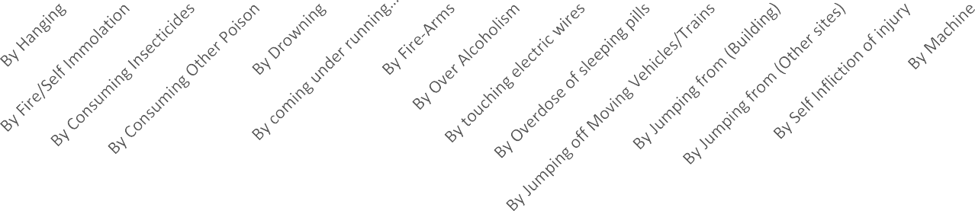

16000  ~~14608~~

14000

12000

10000

8000

6000

4000

2000

0

6239

5870

4862

2781

2059

1591

1045 912 899 882

563

359 323 119

Means Adopted

No. of Suicides

Graph 1.7 is a representation of total number of suicide cases and the means adopted for it in the state of Uttar Pradesh from the year 2001 to 2012. Here we have observed that a large number of cases (14608) were caused by hanging and then by fire/self-immolation (6239 cases) closely followed by consuming insecticide (5870 cases). Least number of cases were caused by machines (119). For graphical representation the data is shown in decreasing order.

ANALYTICAL

#### To test if age group and gender significantly affect the average number of suicides in Uttar Pradesh using two factor ANOVA.

To test the hypothesis-

HOA: Average number of suicides in UP are same in males and females. H1A: Average number of suicides in UP are different in males and females

And

HOB: Average number of suicides in UP are same in different age groups.

H1B: Average number of suicides in UP are different in different age groups.

Table 2.1: Number of suicides distributed according to age and gender with suicides in different years taken as replication.

|  |  |  |  |  |  |  |  |  |  |  |  |  |
| --- | --- | --- | --- | --- | --- | --- | --- | --- | --- | --- | --- | --- |
| **Age** | **Female** | | | | | | | | | | | |
| **2001** | **2002** | **2003** | **2004** | **2005** | **2006** | **2007** | **2008** | **2009** | **2010** | **2011** | **2012** |
| **0-14** | 189 | 624 | 222 | 201 | 177 | 162 | 192 | 207 | 186 | 174 | 171 | 162 |
| **15-**  **29** | 2610 | 2577 | 2556 | 2766 | 2592 | 2211 | 2970 | 3249 | 3207 | 3081 | 3510 | 2967 |
| **30-**  **44** | 1611 | 1563 | 1290 | 1338 | 1419 | 1086 | 1671 | 1557 | 1593 | 1515 | 1848 | 1773 |
| **45-**  **59** | 525 | 720 | 669 | 552 | 624 | 360 | 468 | 453 | 483 | 516 | 603 | 654 |
| **60+** | 210 | 288 | 291 | 192 | 219 | 195 | 303 | 261 | 288 | 237 | 238 | 225 |
|  | **Male** | | | | | | | | | | | |
|  | **2001** | **2002** | **2003** | **2004** | **2005** | **2006** | **2007** | **2008** | **2009** | **2010** | **2011** | **2012** |
| **0-14** | 219 | 165 | 246 | 255 | 174 | 195 | 140 | 180 | 153 | 138 | 135 | 90 |
| **15-**  **29** | 2148 | 2559 | 2289 | 2211 | 1701 | 1887 | 2085 | 2304 | 2508 | 2016 | 2901 | 2535 |
| **30-**  **44** | 1635 | 2298 | 1866 | 1941 | 1839 | 2019 | 1884 | 2274 | 2295 | 1740 | 2991 | 2526 |
| **45-**  **59** | 990 | 1386 | 1089 | 1065 | 1107 | 828 | 1395 | 1257 | 1254 | 1041 | 1554 | 1722 |
| **60+** | 411 | 570 | 471 | 390 | 495 | 354 | 648 | 522 | 507 | 426 | 558 | 609 |

Table 2.2: Two factor ANOVA table with replication

|  |  |  |  |  |  |  |
| --- | --- | --- | --- | --- | --- | --- |
| ***Source of***  ***Variation*** | ***SS*** | ***df*** | ***MS*** | ***F*** | ***P-value*** | ***F crit*** |
| Age | 6417087  5.26 | 4 | 160427  18.81 | 442.95  468 | 4.37608E-  87 | 2.426438  156 |
| Gender | 2911688  1.23 | 2 | 145584  40.62 | 401.97  235 | 3.73902E-  64 | 3.050787  008 |
| Interaction | 3848441  5.38 | 8 | 481055  1.922 | 132.82  390 | 8.16977E-  68 | 1.994904  055 |
| Error | 5975890.  333 | 165 | 36217.5  1717 |  |  |  |
| Total | 1377480  62.2 | 179 |  |  |  |  |

Since, F(Gender)> F critical, we have sufficient evidence to conclude there is significant difference in the mean number of suicides in males and females.

Since, F(Age)> F critical, we have sufficient evidence to conclude there is significant difference in the mean number of suicides in different age groups.

To test which age groups among these have statistically different averages we perform the following Post-hoc test.

#### Post- hoc test:

Table 2.3: Tukey’s HSD test for different age groups

|  |  |  |  |  |
| --- | --- | --- | --- | --- |
| (I) Age | (J) Age | Mean Difference (I-J) | Std. Error | Sig. |
| 0-14 | 15-29 | -43.73* | 3.426 | .000 |
| 30-44 | -29.94* | 3.426 | .000 |
| 45-59 | -12.76* | 3.426 | .003 |
| 60+ | -3.20 | 3.427 | .938 |
| 15-29 | 0-14 | 43.73* | 3.426 | .000 |
| 30-44 | 13.79* | 3.424 | .001 |
| 45-59 | 30.96* | 3.424 | .000 |
| 60+ | 40.53* | 3.424 | .000 |
| 30-44 | 0-14 | 29.94* | 3.426 | .000 |
| 15-29 | -13.79* | 3.424 | .001 |
| 45-59 | 17.17* | 3.424 | .000 |
| 60+ | 26.74* | 3.424 | .000 |
| 45-59 | 0-14 | 12.76* | 3.426 | .003 |
|  | 15-29 | -30.96* | 3.424 | .000 |
|  | 30-44 | -17.17* | 3.424 | .000 |
|  | 60+ | 9.57 | 3.424 | .058 |
| 60+ | 0-14 | 3.20 | 3.427 | .938 |
| 15-29 | -40.53* | 3.424 | .000 |
| 30-44 | -26.74* | 3.424 | .000 |
| 45-59 | -9.57 | 3.424 | .058 |

From the above test, we get the following homogenous subsets-

* + 0-14 years and 60+ years
  + 45-59 years and 60+ years
  + 15- 29 years
  + 30-44 years

This shows tendency of suicides is similar in children (0-14 years) and senior citizens (60+ years). Also, age groups 45-59 years and 60+ years are statistically similar. Other age groups have different average number of suicides.

#### To test if average number of suicides in Uttar Pradesh vary with educational qualification by using ANOVA.

To test the hypothesis-

H0 : Average number of Suicides in UP is independent of Education Status.

v/s

H1: Average number of Suicides in UP depends on Education Status.

Table 2.4: showing number of suicides based on educational qualification with different years taken as replication

|  |  |  |  |  |  |  |  |  |  |  |  |  |
| --- | --- | --- | --- | --- | --- | --- | --- | --- | --- | --- | --- | --- |
| Type | Total Number of Suicides | | | | | | | | | | | |
| Year | | | | | | | | | | | |
| 2001 | 2002 | 2003 | 2004 | 2005 | 2006 | 2007 | 2008 | 2009 | 2010 | 2011 | 2012 |
| No Education | 706 | 1124 | 1036 | 778 | 899 | 827 | 997 | 1130 | 978 | 884 | 1127 | 762 |
| Primary | 760 | 950 | 687 | 764 | 929 | 613 | 772 | 843 | 775 | 654 | 844 | 746 |
| Middle | 829 | 818 | 670 | 648 | 568 | 666 | 775 | 771 | 824 | 602 | 961 | 810 |
| Matriculate/Secondary | 673 | 805 | 620 | 754 | 592 | 476 | 682 | 675 | 735 | 691 | 1029 | 885 |
| Hr. Secondary/ Intermediate/Pre- University | 403 | 404 | 473 | 503 | 338 | 330 | 514 | 469 | 586 | 564 | 658 | 757 |
| Diploma | 16 | 28 | 41 | 66 | 30 | 70 | 70 | 53 | 66 | 48 | 52 | 101 |
| Graduate | 113 | 101 | 116 | 98 | 74 | 82 | 89 | 101 | 155 | 150 | 133 | 301 |
| Post Graduate and Above | 16 | 20 | 20 | 26 | 19 | 35 | 28 | 46 | 39 | 35 | 39 | 60 |

Table 2.5: Summary of the above data

|  |  |  |  |
| --- | --- | --- | --- |
| *Groups* | *Sum* | *Average* | *Variance* |
| No Education | 11248 | 937.3333 | 22638.06 |
| Primary | 9337 | 778.0833 | 10312.45 |
| Middle | 8942 | 745.1667 | 13103.24 |
| Matriculate/Secondary | 8617 | 718.0833 | 20336.99 |
| Hr. Secondary/Intermediate/Pre-  University | 5999 | 499.9167 | 16197.17 |
| Diploma | 641 | 53.41667 | 537.3561 |
| Graduate | 1513 | 126.0833 | 3672.992 |
| Post Graduate and Above | 383 | 31.91667 | 169.1742 |

Table 2.6: ANOVA Table for single factor analysis

|  |  |  |  |  |  |  |
| --- | --- | --- | --- | --- | --- | --- |
| *Source of Variation* | *SS* | *df* | *MS* | *F* | *P-*  *value* | *F crit* |
| Between Groups | 11197172 | 7 | 1599596 | 147.1444 | 9.29E-  46 | 2.11547 |
| Within Groups | 956641.8 | 88 | 10870.93 |  |  |  |
| Total | 12153814 | 95 |  |  |  |  |

Since, F > F critical, ( p-value tending to 0), we have sufficient evidence to reject the null hypothesis and can conclude that the number of suicides in UP depends on education status.

From the above data, we can see number of suicides decreases with higher educational qualification.

#### Post- hoc Test-

Table 2.7: Tukey HSD Test for different education status

|  |  |  |  |  |
| --- | --- | --- | --- | --- |
| (I) Type | (J) Type | Mean Difference (I-J) | Std. Error | Sig. |
| No Education | Diploma | 441.96* | 19.429 | .000 |
| Graduate | 405.63* | 19.429 | .000 |
| Hr. Secondary/Intermedia e/Pre-University | 218.71* | 19.429 | .000 |
| Matriculate/Secondar | 109.63* | 19.429 | .000 |
| Middle | 96.08* | 19.429 | .000 |
| Post Graduate and Above | 452.71* | 19.429 | .000 |
| Primary | 79.63* | 19.429 | .002 |
| Primary | Diploma | 362.33* | 19.429 | .000 |
| Graduate | 326.00* | 19.429 | .000 |
| Hr. Secondary/  Intermediate/Pre- University | 139.08* | 19.429 | .000 |
| Matriculate/Secondar | 30.00 | 19.429 | .782 |
| Middle | 16.46 | 19.429 | .990 |
| No Education | -79.63* | 19.429 | .002 |
| Post Graduate and Above | 373.08* | 19.429 | .000 |

|  |  |  |  |  |
| --- | --- | --- | --- | --- |
| Middle | Diploma | 345.87* | 19.429 | .000 |
| Graduate | 309.54* | 19.429 | .000 |
| Hr. Secondary/Intermedia e/Pre-University | 122.62* | 19.429 | .000 |
| Matriculate/Secondar | 13.54 | 19.429 | .997 |
| No Education | -96.08* | 19.429 | .000 |
| Post Graduate and Above | 356.62* | 19.429 | .000 |
| Primary | -16.46 | 19.429 | .990 |
| Matriculate/Secon dary | Diploma | 332.33* | 19.429 | .000 |
| Graduate | 296.00* | 19.429 | .000 |
| Hr. Secondary/Intermedia e/Pre-University | 109.08* | 19.429 | .000 |
| Middle | -13.54 | 19.429 | .997 |
| No Education | -109.63* | 19.429 | .000 |
| Post Graduate and Above | 343.08* | 19.429 | .000 |
| Primary | -30.00 | 19.429 | .782 |
| Hr. Secondary/Interm | Diploma | 223.25* | 19.429 | .000 |
| Graduate | 186.92* | 19.429 | .000 |
| Matriculate/Secondar | -109.08* | 19.429 | .000 |

|  |  |  |  |  |
| --- | --- | --- | --- | --- |
| diate/Pre- University | Middle | -122.62* | 19.429 | .000 |
| No Education | -218.71* | 19.429 | .000 |
| Post Graduate and Above | 234.00* | 19.429 | .000 |
| Primary | -139.08* | 19.429 | .000 |
| Diploma | Graduate | -36.33 | 19.429 | .573 |
| Hr. Secondary/Intermedia e/Pre-University | -223.25* | 19.429 | .000 |
| Matriculate/Secondar | -332.33* | 19.429 | .000 |
| Middle | -345.87* | 19.429 | .000 |
| No Education | -441.96* | 19.429 | .000 |
| Post Graduate and Above | 10.75 | 19.429 | .999 |
| Primary | -362.33* | 19.429 | .000 |
| Graduate | Diploma | 36.33 | 19.429 | .573 |
| Hr. Secondary/Intermedia e/Pre-University | -186.92* | 19.429 | .000 |
| Matriculate/Secondar | -296.00* | 19.429 | .000 |
| Middle | -309.54* | 19.429 | .000 |
| No Education | -405.63* | 19.429 | .000 |
| Post Graduate and Above | 47.08 | 19.429 | .236 |

|  |  |  |  |  |
| --- | --- | --- | --- | --- |
|  | Primary | -326.00* | 19.429 | .000 |
| Post Graduate an Above | Diploma | -10.75 | 19.429 | .999 |
| Graduate | -47.08 | 19.429 | .236 |
| Hr. Secondary/Intermedia e/Pre-University | -234.00* | 19.429 | .000 |
| Matriculate/Secondar | -343.08* | 19.429 | .000 |
| Middle | -356.62* | 19.429 | .000 |
| No Education | -452.71* | 19.429 | .000 |
| Primary | -373.08* | 19.429 | .000 |

d

From the test above, we get the following homogenous subsets-

* + No education
  + Primary, Middle, Matriculate
  + Intermediate/ Pre-University
  + Diploma, Graduate, Post- Graduate

These subsets are statistically homogenous within but heterogeneous among one another in terms of the total number of suicides committed in Uttar Pradesh from 2001 to 2012.

#### Suicides in Students-

Table 2.8: Number of students who committed suicide from 2001- 2012 according to their gender

|  |  |  |  |
| --- | --- | --- | --- |
| Year | Gender | |  |
| Female | Male | Total |
| 2001 | 88 | 123 | 211 |
| 2002 | 96 | 120 | 216 |
| 2003 | 98 | 118 | 216 |
| 2004 | 73 | 128 | 201 |
| 2005 | 79 | 140 | 219 |
| 2006 | 69 | 102 | 171 |
| 2007 | 126 | 148 | 274 |
| 2008 | 154 | 200 | 354 |
| 2009 | 143 | 203 | 346 |
| 2010 | 161 | 156 | 317 |
| 2011 | 106 | 153 | 259 |
| 2012 | 151 | 154 | 305 |

Graph 2.1: Gender-wise trend of number of students who committed suicide from 2001-2012

250

200

**200**

**203**

150

**148**

**154**

**1516**

**153**

**1541**

**140**

**143**

**123**

**128**

**120**

**126**

**118**

100

**96**

**98**

**102**

**106**

Gender Female

Gender Male

**88**

**73**

**79**

**69**

50

0

2001 2002 2003 2004 2005

2006 2007 2008

Gender

2009 2010 2011 2012

No. of Suicides

From the graph above, we see a general upward trend in the number of both male and female students who committed suicide in Uttar Pradesh from 2001-2012. Thus, we find simple linear trend of the total number of suicides by students in Uttar Pradesh below by using least square method as a function of time.

Graph 2.2: Trend line for number of suicides by students in Uttar Pradesh with time by using least-square fit

400

354

346

350

317

305

300

274

259

250

211

216

216

219

**y = 11.752x + 181.03**

201

200

171

150

100

50

0

1

2

3

4

5

6

7

8

9 10 11 12 13 14

Time

Number of Suicides

By the above graph, using least square fitted line for the number of suicides by students in Uttar Pradesh between 2001 and 2012, we obtain the simple linear trend as-

Y= 181.03 + 11.752x

i.e. on an average, almost 12 more students commit suicide than the previous year in Uttar Pradesh due to different reasons. This trend raises an alarm towards the mental health condition of the students, for whatever reasons that might be. This also encourages us to look for ways to make students aware about how to cope up with their thoughts and surroundings and deal with different unfavorable conditions.

#### Suicides in people associated with farming/ farming activities-

Table 2.9: representing the year-wise number of suicides by farmers or those associated with agricultural activities

|  |  |
| --- | --- |
| Year | Number |
| 2001 | 688 |
| 2002 | 525 |
| 2003 | 387 |
| 2004 | 496 |
| 2005 | 522 |
| 2006 | 411 |
| 2007 | 486 |
| 2008 | 745 |
| 2009 | 656 |
| 2010 | 548 |
| 2011 | 645 |
| 2012 | 745 |

Graph 2.3: representing the year-wise number of suicides by farmers or those associated with agricultural activities

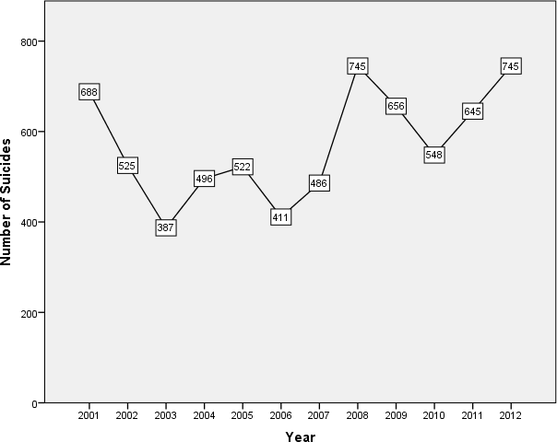

We observe that the number of suicides among the farmers or those associated with agricultural related activities with considerably more in the year 2001, then in year 2008 and finally in 2012. The pattern can be associated with the 2001 Economic crisis and the Global Recession of 2008 that saw an end in 2012.

# CONCLUSION

* + Representation of number of suicides by age and gender showed that cases of suicides were higher in females than males for younger age groups (0-14 years and 15-29 years) whereas cases were higher in males for older age groups (30-44 years, 45-59 years and 60+ years). Suicides were the highest in age group 15-29 years for both the genders that coincide with the world’s and

country’s data.

* + Study of different causes of suicides by people of Uttar Pradesh showed family problems followed by the matters of dowry dispute being the most common cause of suicides.
  + Analysis of professional profile of people who committed suicide showed housewives were the major fraction among females who committed suicides. On the other hand, among males, those associated with farming or agricultural activities and unemployed were the most prominent fraction.
  + Descriptive analysis of various means adopted for committing suicide showed that hanging was the most common means of suicide. Self-immolation and consumption of poison also formed a significant fraction.
  + Sufficient evidence was found to conclude there is significant difference in the mean number of suicides in different age groups.
  + Sufficient evidence was found to conclude there is significant difference in the mean number of suicides in males and females.
  + A statistically significant effect of educational qualification was found on the average number of suicides in Uttar Pradesh with people with no education being the group most prone to suicides, followed by people with primary, middle or matriculate level of education, followed by people having intermediate level of education and least in graduates and post graduates.
  + An increasing linear trend was found in the number of suicides by students in Uttar Pradesh, given by the equation-

Y= 181.03 + 11.752x

This points towards the deteriorating mental health of the students every year.

* + There was a pattern observed in the number of suicides by farmers and those associated with agricultural activities that coincided with the global recession cycle.